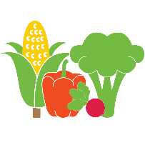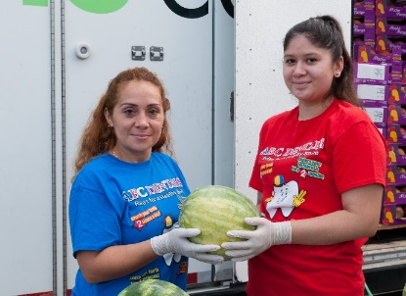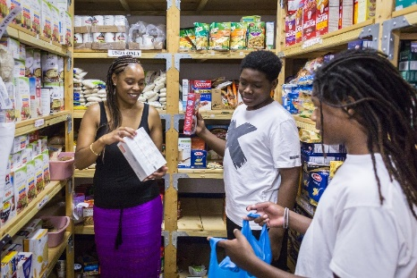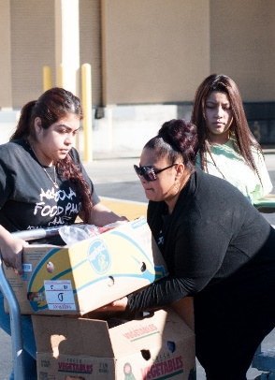

**Dates:** **November 11, 2022**

**November 18, 2022**

**December 9, 2022**

**December 16, 2022**

**January 13, 2023**

**January 27, 2023**

**February 10, 2023**

**February 24, 2023**

**March 10, 2023**

**March 24, 2023**

**April 14, 2023**

**April 28, 2023**

**May 12, 2023**

**May 26, 2023**

**Place: Chavez High School**

**On Galveston Rd.**

**Time: 9AM-12PM**

**Or until supplies last**

**Contact:**

**Mr. Soto – Wraparound Specialist**

**Twitter: @ChavezHSWrap**

**Please bring bags, boxes or carts. Not a drive thru!**

***Run by students for students.***

Visit the School Market – located on your campus. Get healthy food for the energy you need to have a successful school year.

**What will be available:**

Fresh Produce

Grains

Dry Beans

Meat

A variety of shelf stable items

**Meet your**

**School Market Crew!**

Max

Rebecca

Arely

Ruben

Breanna

Mia

Paris

Crystal

Christopher

Jennifer

Noah

Kimberly

Maria

Julio

Jhadia

Rodner

Leila

Fernanda

Dayanara

Belen

Abbania

Giselle

Valery

Jocelyn

Joselyn

Debany

Imyria

Rachel

Alvin

For more information contact: Mr. Soto at (713) 495-6950 or Mark.Soto@houstonisd.org